**SUMMARY**

* The School of Computing is now able to host web content using two different Linux web servers. There is one server for Faculty and one server for Students.
* The Student Web URL format is: <https://student.computing.gvsu.edu/USERID> (where the USERID is the GVSU userID of the individual).
* The Faculty Web URL formation is: <https://faculty.computing.gvsu.edu/USERID> (where the USERID is the GVSU userID of the individual).
* All students enrolled in any CIS course will be given a directory to publish web content
* All faculty and staff within the CIS department will be given a directory to publish web content.
* All faculty, staff, and students will also have one MySQL database created for them, in case their website needs a MySQL database.

**Note: replace the FACULTY with STUDENT for all the forthcoming examples:**

**HOW TO PUBLISH CONTENT TO THE WEB USING THE SCHOOL OF COMPUTING WEB SERVERS:**

1. Connect to EOS using SSH and your standard GVSU credentials:  
   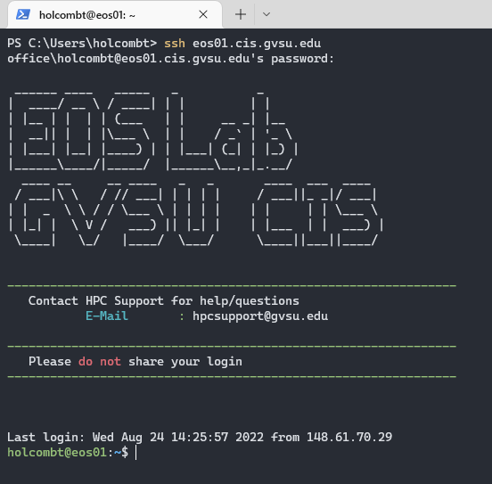
2. There are now 2 directories located on the root of all School of Computing lab computers: /WEB_STUDENT and /WEB_FACULTY  
   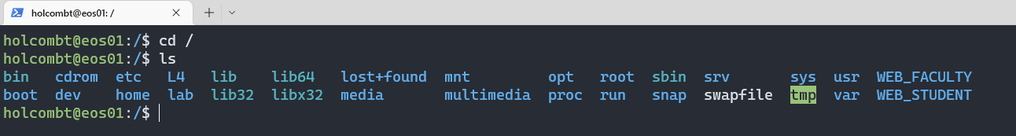
3. Within the WEB_STUDENT directory is a directory for every student enrolled in a CIS course
4. Within the WEB_FACULTY directory is a directory for all faculty and staff in the School of Computing department
5. If you change directories into either of these folders, notice that you can’t read or list the contents of these directories due to the permissions that are set  
   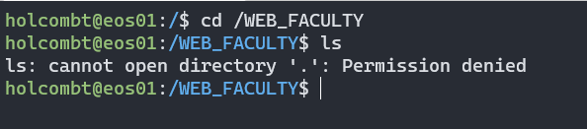
6. Instead, change directories directly to your personal WEB directory  
   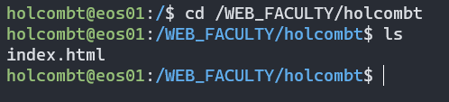
7. Within your personal web directory, you can publish HTML, CSS, JavaScript, and PHP files that will be visible on the web. Here is an example of Tom’s WEB_FACULTY directory and his index.html web page:  
   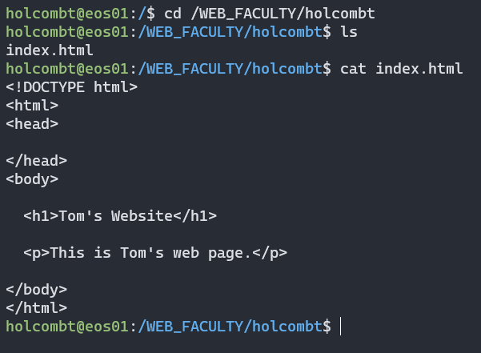
8. Navigating the Tom’s webpage using the standard Faculty Web URL (<https://faculty.computing.gvsu.edu/holcombt>) will display this simple HTML web page:

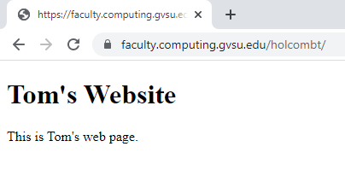

**SECURITY AND POLICIES**

1. IT reserves the right to remove the public facing development environment and require VPN if security concerns are identified.

2. IT/Computing will re-visit the student computing environment in 10 months and discuss the success and issues with the public facing development environment.

3. No use of copyrighted photos.

4. If IT identifies a project/site as vulnerable we will disable/offline that project until remedied.

5. Students should archive their content 1 year after graduation, removal of the site will be automated for those students 1 year after graduation.

6. Faculty will outline/explain to students the need to make sure their projects comply with DSR regulations

7. Faculty will monitor these projects and pages to ensure there is no inappropriate content.

8. A condition of use by computing students is provided to students at the start of the semester.